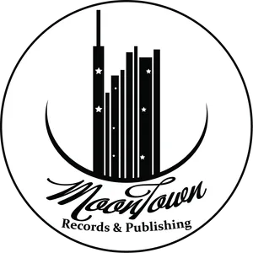

Brown Girl Book Tour Vendor Application Form
Vendor Information

Business Name: __________________________________
Contact Name: __________________________________
Email Address: __________________________________
Phone Number: ___________________________________
Website (if applicable): ___________________________
Product/Service Description ________________________
_________________________________________________
_________________________________________________
_________________________________________________
Payment Information - Vendors Fee - $50.00
Payment Method:
Credit Card _____________________________ Exp ___/___
CVC ____________
Cash App ___________________
Payment is due with the application and should be made to MoonTown Records and Publishing
MoonTown Cash App ________________

Vendor Agreement

I, the undersigned, agree to abide by the rules and regulations set forth by the Brown Girl Book Tour. I understand that failure to comply may result in the termination of my vendor privileges without refund.

Signature: ______________________________________
Printed Name: _________________________________________
Date: ____________________________
Submission Instructions ____________________________
__________________________________________________

Please submit completed applications to:

Attn: Amanda Sherman
Email: asherman@moontownent.com

For Internal Use Only

Date Received: ____________________________
Payment Received: _________________________
Approved By: ______________________________
Date Approved: ______________________________

